

## PAF-KIET NORTH CAMPUS

**COMPILER CONSTRUCTION**

**CLASS ID: (106395)**

**PROJECT REPORT**

|  |  |
| --- | --- |
| **GROUP MEMBER:**  **ALIZA IMAM (62007)** |  |

We aim to construct a compiler for a subset of a programming language Mini C in 3 phases. Code Optimization and Machine Code generation is not the scope of the project. These phases include:

* Phase I: Lexical Analyzer (Laxer)
* Phase II: Syntax Analyzer (Parser)
* Phase III: Semantic Analyzer

# SAMPLE LANGUAGE:

## MINI C:

Mini C is a simple subset of the standard C language. It does not include arrays, structs, unions, files, sets, switch statements, do statements, or many of the low level operators. The only data types permitted are int and float.

## SAMPLE CODE:

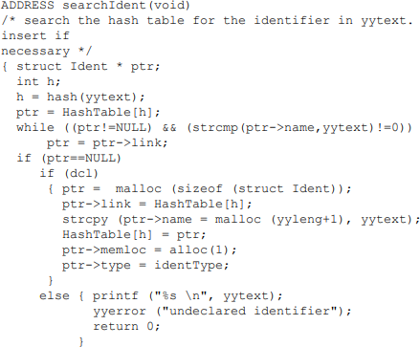

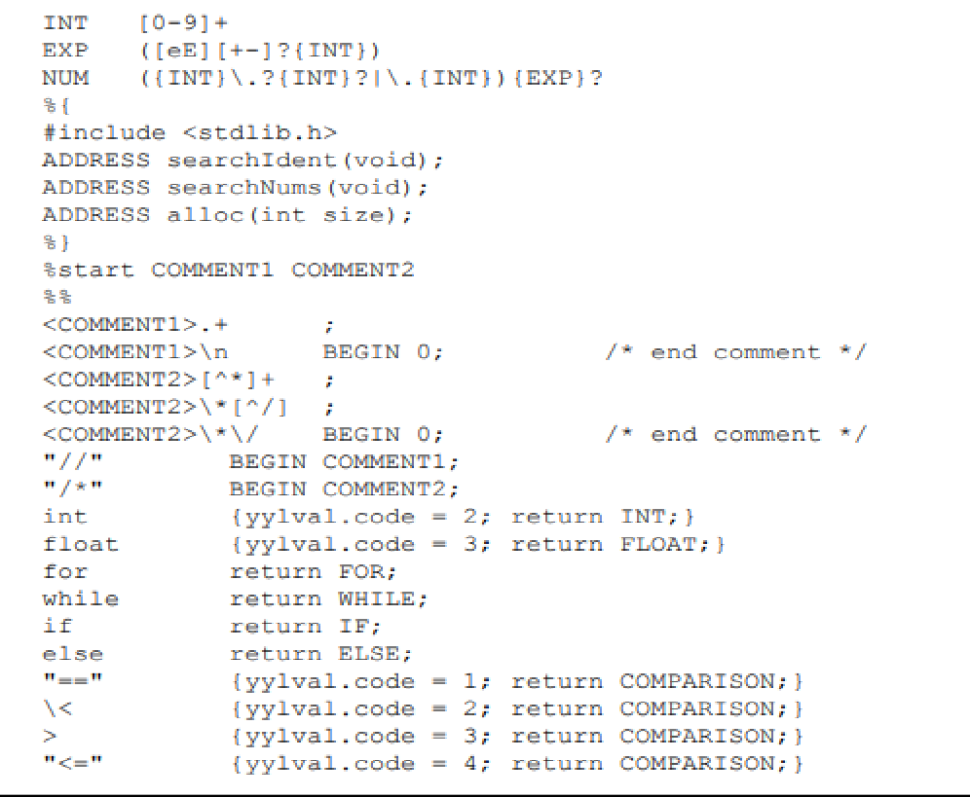

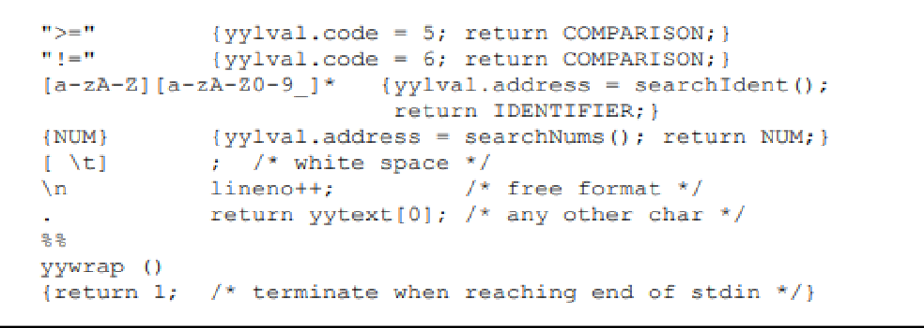

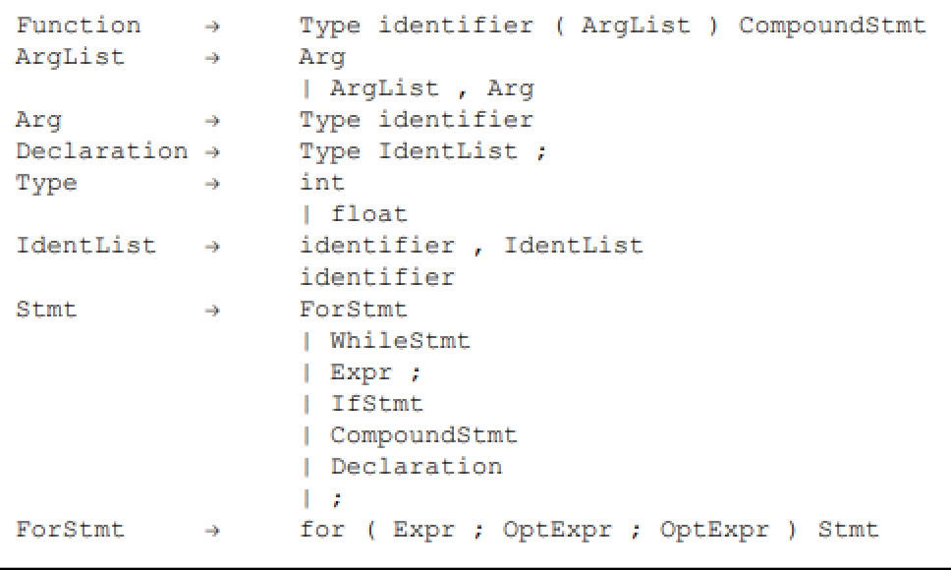

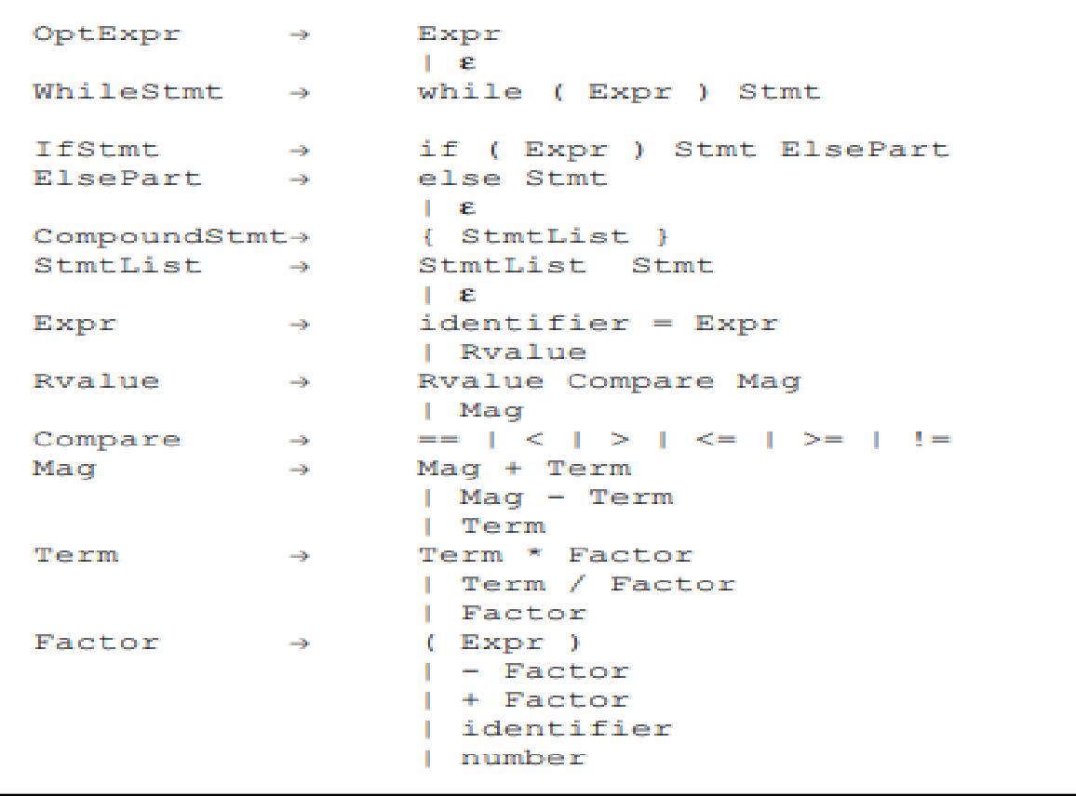

**PROBLEM 1: NEW TO THE LANGUAGE**

The language was new for all of us. It takes too much time to understand but we did our best to learn it and implement it.

**PROBLEM 2: WINDOW CORRUPTED**

When I installed virtual machine on my PC, windows got corrupted.

**PROBLEM 3: PROJECT LOAD & LOCKDOWN**

We all have project load on ourselves as well as FYP is also going on.